PROJECT DEVELOPMENT PHASE DELIVERY OF SPRINT-2

|  |  |
| --- | --- |
| DATE: | 05 NOV 2022 |
| TEAM ID: | PNT2022TMID39958 |
| PROJECT: | AI-Powered Nutrition Analyzer for Fitness Enthusiasts |
| MAXIMUM MARKS: | 8 marks |

# PREREQUISITES:

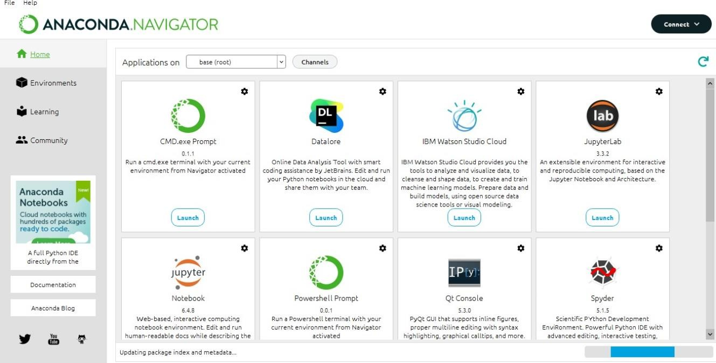For this project we must download and install anaconda navigator, python, Jupyter notebook and pip libraries.

CREATING A GIT HUB ACCOUNT:

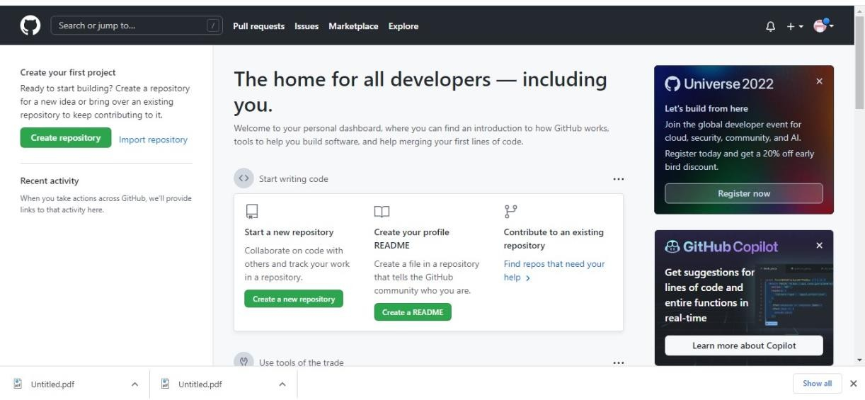

# PRIOR KNOWLEDGE:

Understand and learn about the deep learning concepts such as;

1. CNN
2. OpenCV
3. Flask

# DATA COLLECTION:

Collect the data sets required. Create two different folders for test data and train data.

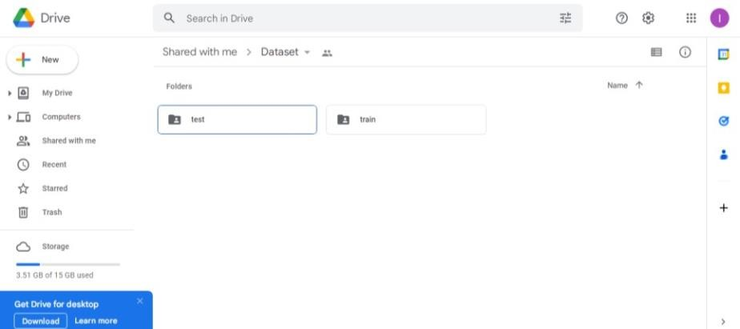

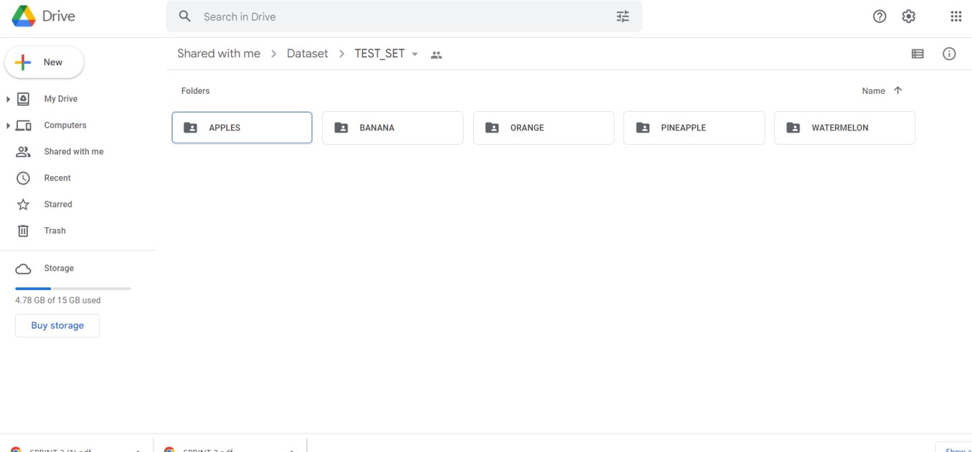TEST DATA:

TRAIN DATA:

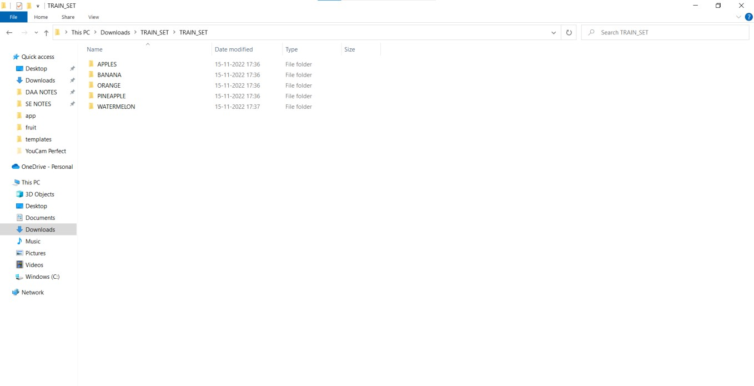

APPLE:

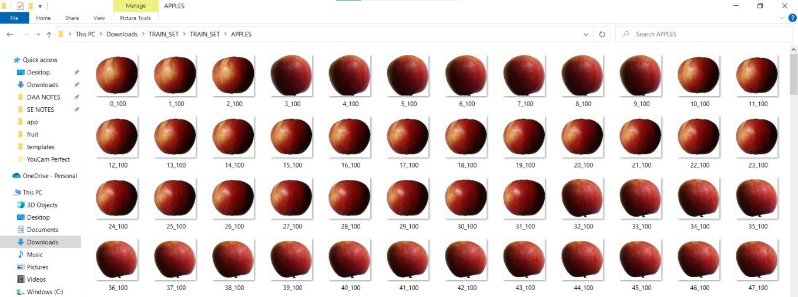

# MODEL BUILDING:

Model building involves a chain of tasks to be completed like

* 1. 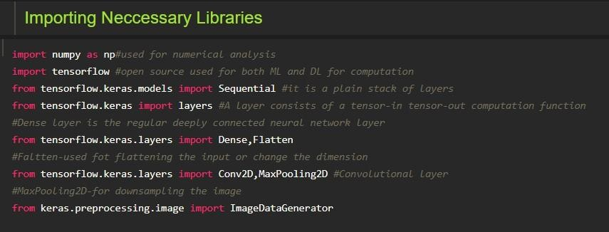Importing model building libraries
  2. Initializing the model



* 1. Adding CNN layers

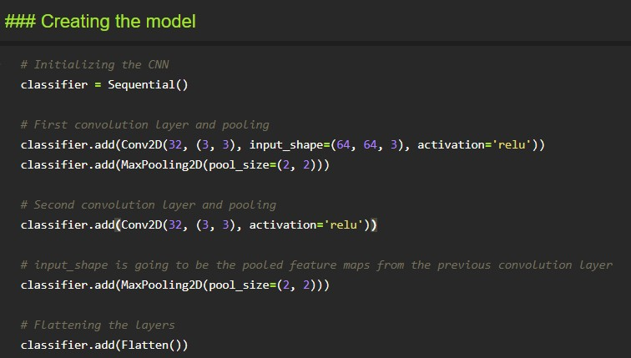

* 1. Train, save and test the model

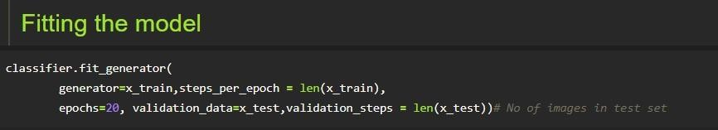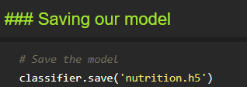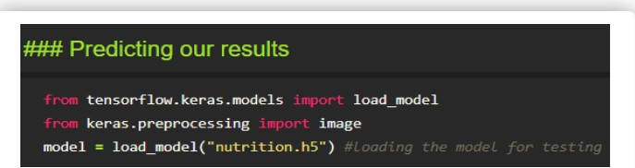

Taking an image as input and checking the results

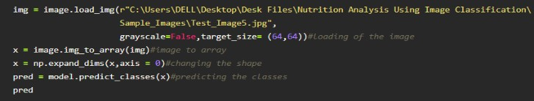

By using the model we are predicting the output for the given input image



The predicted class index name will be printed here.